Lesson 4 Demo 7
Merging Branches in Git

Objective: To merge branches in Git

Tools required: Git

Steps to be followed:
- Create a new branch
- Create a new file in the new branch
- Switch to the main branch
- Merge the branches
- Push the changes to the remote repository
Note: A projectfile is already created in Lesson 4 Demo 5. If you do not have the repository, first perform that demo and then execute the steps from this demo.
Step 1: Create a new branch
1.1 Open the Terminal in your lab, and navigate to the sample-repository folder
cd projectfile
1.2 Execute the following command on the terminal to create a new branch:
git branch sample_branch
git branch
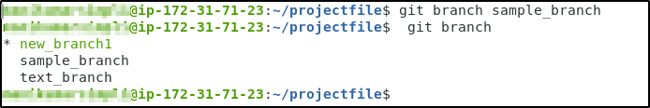

Step 2: Create a new file in the sample_branch
2.1 Use the following command to switch to the sample_branch:
git checkout sample_branch
2.2 Use the following commands to create an empty HTML file index1.html, and add it to the test_branch:
touch index1.html
git add index1.html
git commit -a -m "index1.html added to the sample_branch"
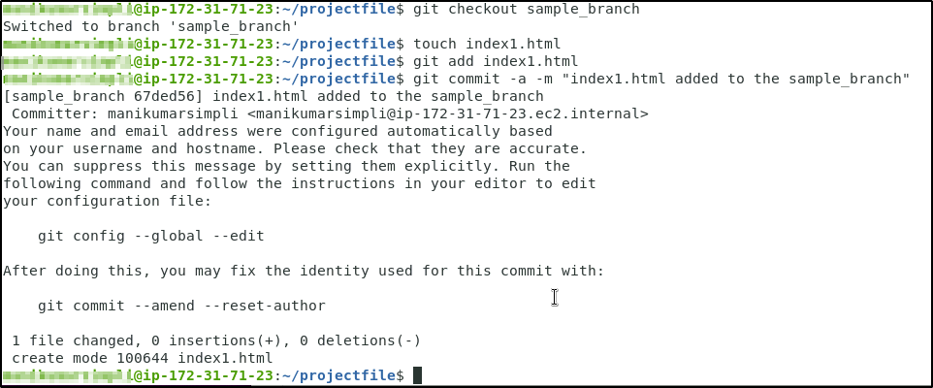

Step 3: Switch back to the main branch
3.1 Use the following command to switch back to the main branch:
git checkout new_branch1
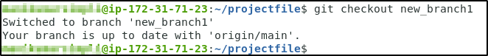

Step 4: Merge the branches
4.1 Use the following command to merge the sample_branch to the main branch:
git merge sample_branch
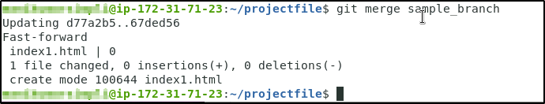
Step 5: Push the changes to the remote repository
5.1 Use the following command to push the new_branch1 to the remote repository:
git push -u origin new_branch1
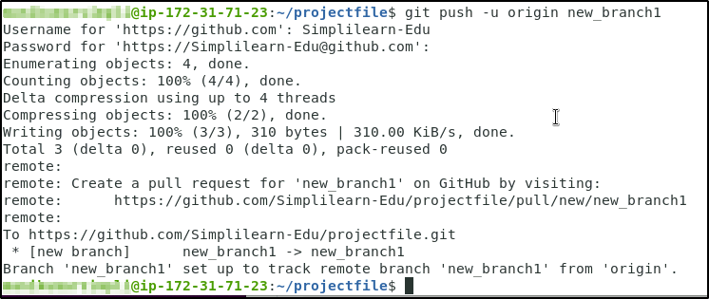

5.2 Go to the remote repository to check whether the branch is updated

